Introduction
Hi! A little while ago, I wanted to set up GitHub’s Command Line Interface on my Linux machine. Millions of people use this every day to push and pull code, so I figured it’d be pretty easy to set up.
Since I’m writing this (and given you’re reading this), you may have guessed that it was not particularly straightforward. The title is also pretty clear! :-P
Dumdum, smoothbrain, idiot; A rose by any other name would smell as sweet still mess up. That’s why I’m writing this guide. It’s pieced together from all the random resources I had to find. Either I’m extraordinarily bad at looking things up, or this process was just not clear. I messed up many, many times. I won’t, however, tell you what I did wrong, as to prevent any confusion. Some of you may not speak English fluently, and assume some error I’m showing is part of the process.
And lastly, I’m not a pro. I’ll be writing this in a way that makes sense to me. This is part tutorial, part step-by-step archive for me to follow when I inevitably forget how to do this on another machine.

So without any further ado:

Initial steps
This will be done on a brand new VM. It’s currently early 2025, and as guides get outdated, I figure it’s important to mention this. It’s a Tumbleweed install, with XFCE. Hopefully some of you new-to-Linux readers will be curious as to what Tumbleweed is exactly. (A wonderful distro I implore you to give a spin!) But that’s beside the point. XFCE, as this will be a brand new, throwaway device. Might as well have something that’s lean and mean! :-)

First things first: sign into GitHub. This should be pretty straightforward.
You’ll also be creating a repo from the website. Mine will be titled “GITHUB-TUTORIAL”, for obvious reasons.
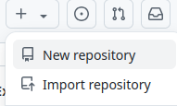

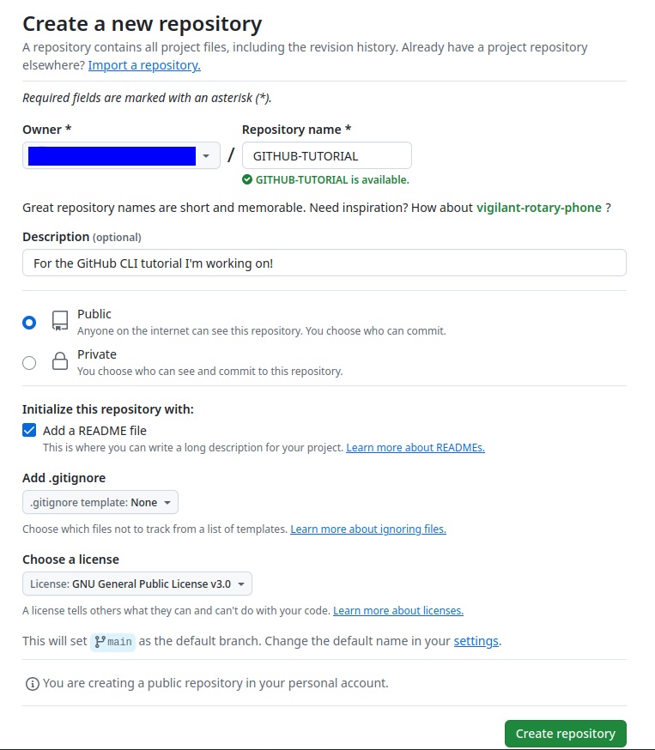

Then, make sure you’ve got “git” AND “gh” installed. They’re Git and GitHub’s CLI, respectively.
In my case, I’d type: sudo zypper install git gh
For Debian/Ubuntu users: sudo apt install git gh
If you’re on a different distro or use a different package manager, substitute the zypper/apt and see what it pulls up. It should be fairly similar across most distros. :-)

This is what it looks like for me: 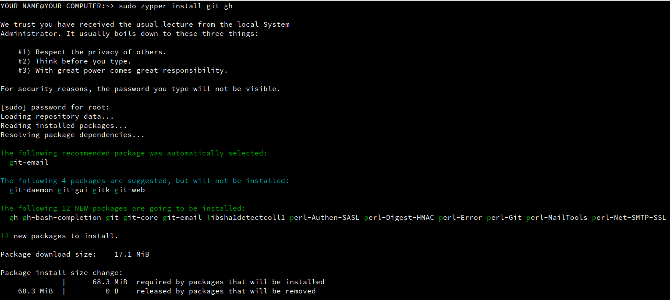

Setting up SSH Key
Now we’re going to go ahead and set up the SSH key. SSH keys are fascinating things, and far too complex for me to explain. For now, just know it’s a fancy handshake to identify your machine as “yours” to GitHub. (Which isn’t exactly how that works, but… This is a simple GitHub CLI tutorial, not a deep dive into SSH. :-P )

This is what you’ll do on your device:

cd ~
We go into our home folder (In my case, it’s “/home/YOUR-NAME”.)
mkdir .ssh
We create a folder called “.ssh”. The beginning dot signifies it’s hidden. If you can’t see the folder you just created in your file manager of choice, try pressing CTRL+H!

cd .ssh
We then change directory into this newly-created .ssh folder.
You can call the folder anything you want, but for clarity and convenience, .ssh works.
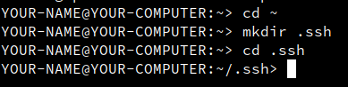

And now, we’ll create the key(pair). Don’t close your terminal! If you already did, just cd back into .ssh!
ssh-keygen -b 4096 -t rsa
This will go and ask several questions.
For the name (the “file”), I’m picking “GitHub”. That makes it clear to me exactly what this keypair is for. You could go with the defaults, or with a different name, but then the next few steps will have to be omitted or adjusted. It’s up to you!
I highly recommend picking a secure passphrase, too.
Once that’s done, you’ll see this neat gibberish:
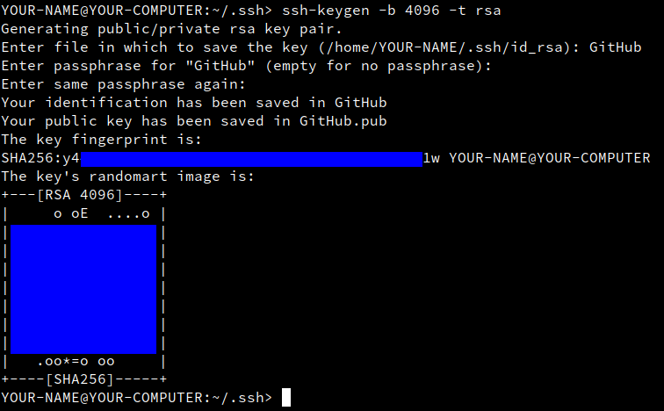
The blue is mine. For obvious reasons, I’m redacting the “sensitive” parts. :-)

touch ~/.ssh/config
We’re creating (“touching”) a file called “config” in our .ssh folder.
chmod 600 ~/.ssh/config
This is a little more cryptic. We’re changing the mode to 600. This means that the owner (you) has full read and write access to the file, but no other user can access it.
nano config (We're editing this file in there now.)
And now we’ll be editing the file in nano. You can use any text editor for this, but nano is just so quick to use.
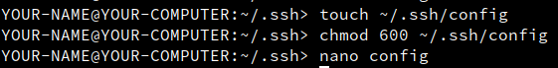

You’ll copy and paste this exactly:

Host github.com
User git
IdentityFile ~/.ssh/GitHub

(CTRL+SHIFT+V ought to work!)
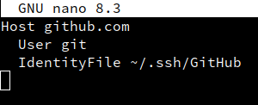

If you called your file something else, replace “GitHub” here. For example, if you called it “devkey”, you’d copy and paste this:

Host github.com
User git
IdentityFile ~/.ssh/devkey

Don’t worry, I’ll explain this soon! You should never blindly trust random things from some Tnobody on the internet, which is why I’m trying my best to explain in detail everything we’re doing.

Anyway, save and quit. In nano, you’d press CTRL+O (To “write out”, as in saving.), enter (make sure the file name is still “config”) , and CTRL+X to quit.

Now we’ll copy our .pub key. Make sure you’re copying from the file ending in .pub!
On GNOME, use this: gnome-text-editor GitHub.pub
On KDE, Kate works great: kate GitHub.pub
Or in my case, on XFCE: mousepad GitHub.pub

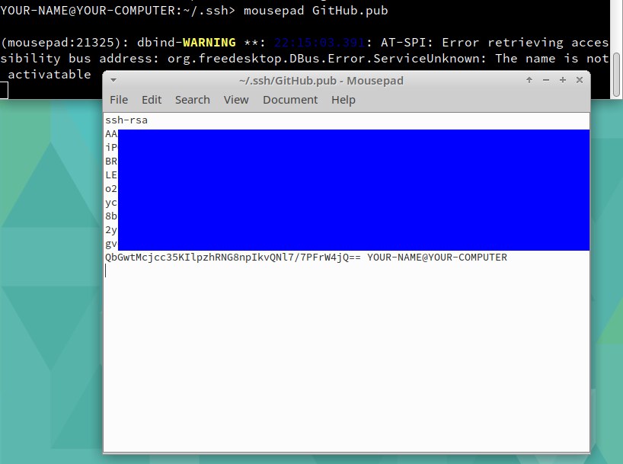

There might be a newline at the end, which is part of the key. A GUI makes this more obvious, in my experience.

Copy the entire key and put it here: https://github.com/settings/keys

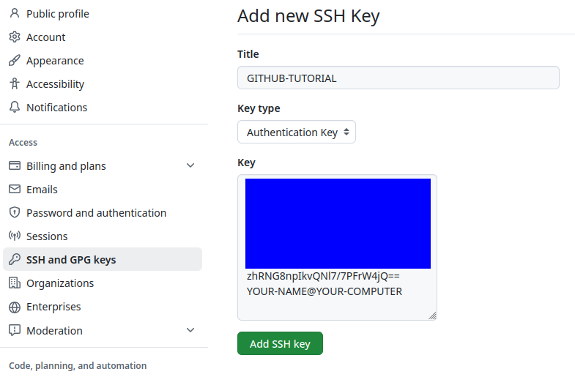

Then just click “Add SSH Key”, and this tedious part is done.
(You may be asked to verify on mobile, or through other 2FA options. 2 Factor Authentication is highly recommended!)

This short guide by Kyle DeGuzman was instrumental in helping me set everything up the first time. Many thanks! It inspired me to make this guide. https://medium.com/@kyledeguzmanx/quick-step-by-step-guide-to-generating-an-ssh-key-in-github-d3c6f7e185bb

Actually connecting to GitHub
Now we will test whether or not we can actually connect to the GitHub SSH server with this command: ssh -vT git@github.com
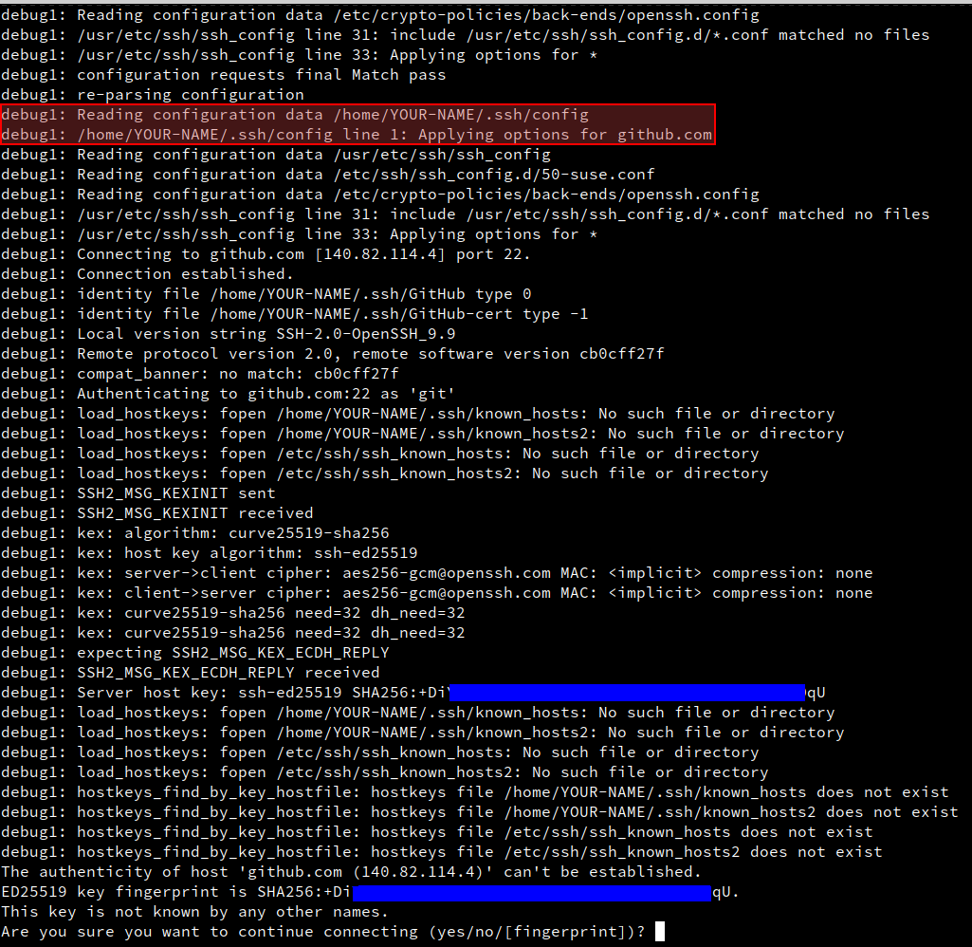
Assuming you haven’t previously connected, you will be prompted to type “yes”. This will add GitHub to your known hosts. SSH is another pretty complex topic, so you don’t have to take my word for it. I recommend digging into SSH if you’re not familiar with it.

But one of the most important parts (and the reason I’m including this screenshot) is the bit highlighted in red. See how it’s checking the config file for where to find our GitHub.pub key? Without this little file, GitHub wouldn’t have been able to find the key. A default-named key would not have had any issues getting discovered.

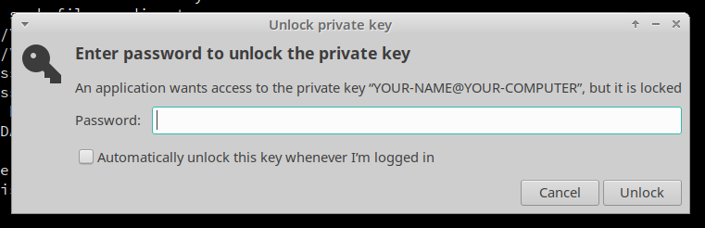
If you added a passphrase (which I recommended doing), you’ll be prompted for it now. This dialog will probably look a little different, if you’re not using XFCE, but it’ll ask for the same thing.

After entering your passphrase (note that the dialog does ask for a “password”. This inconsistent phrasing is one of the things that tripped me up while I was initially setting everything up. Hence why I’m pointing it out and intentionally using “passphrase” . :-) )

Then a few more lines of text, going over the pubkey and hostkey, but we’re looking for this very important bit near the end: Hi YOUR-GITHUB-NAME! You've successfully authenticated, but GitHub does not provide shell access.

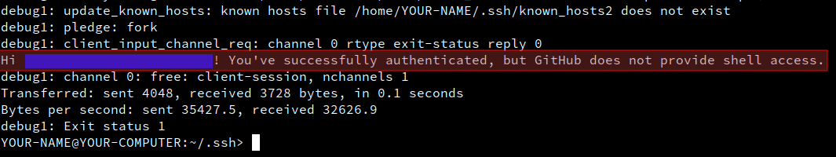

If you see this, great! That means the key setup worked great.
This can fail for a variety of reasons. Looking up the error code will be a great place to start, but hopefully you won’t need to. :-)

Time to authorize!

All right, we’re almost done! It’s time to authorize, well, “me”, to GitHub. Proving that I am me and that this is my account.

I recommend closing the previous terminal, and opening a new one. And this will be our first command: gh auth login
This will launch an interactive prompt. It should be fairly self-explanatory!
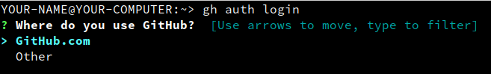

Make sure “GitHub.com” is selected, and press enter.

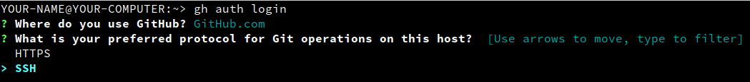

Our preferred protocol will be SSH, so press the down arrow key, and enter.



Yes, we’ll be uploading our GitHub.pub (or “devkey.pub”, or whichever, as long as it’s ending in .pub, and was the one we copied earlier!), so just enter this time.



This title can be anything, but “GitHub CLI” is very straightforward. That’s the “default”, so you can just press enter here.

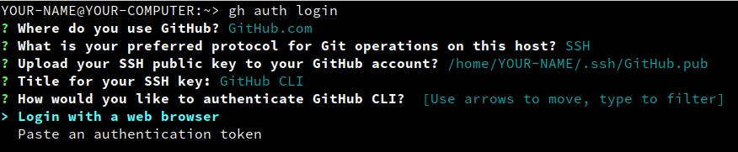

And finally, authentication! This is up to you, but for convenience, I’ll select “Login with a web browser”.

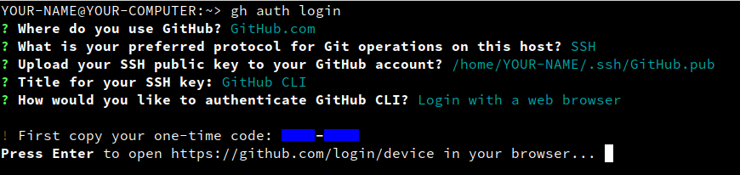

Go ahead and copy that 8-character code. It’ll be something like B3FC-HN3M. Just highlight your code, right-click, and select “Copy”. (The usual copy shortcut, CTRL-C, may interrupt or “cancel” the command, which we don’t want to do! :-) )
Then press enter, and your browser will open with a GitHub Device Activation prompt. Click on “Continue”, paste (CTRL-V) your code, and click “Continue” again.

Now you’ll get a fairly scary-looking page.
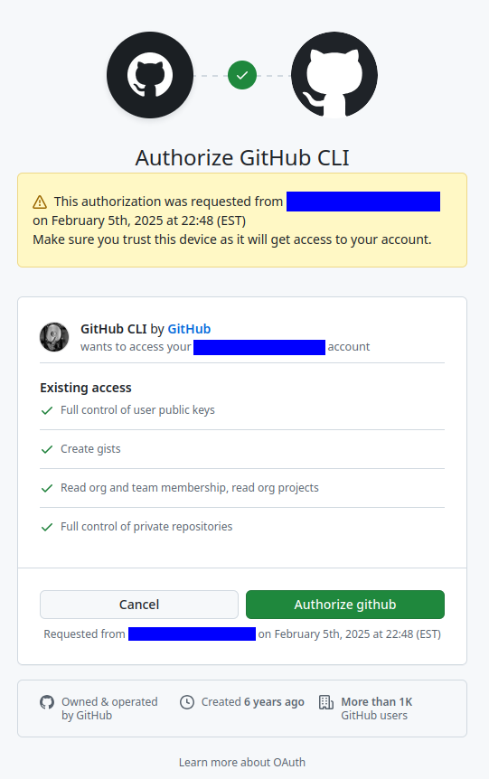
This pop-up will show an approximate city and the IP address from where the request was initiated. This should look correct. After making sure that these things line up, press “Authorize github”.

And finally, a very relieving message:

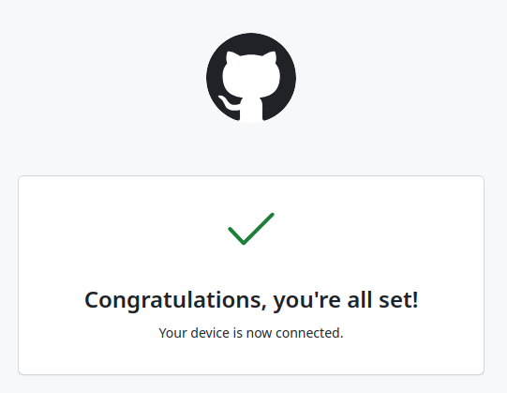

The terminal will show a few more messages however.
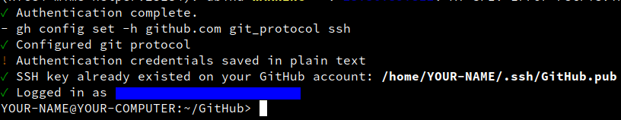
This will confirm that the authentication went through correctly, that the GitHub.pub key was already in our account, and that we’re logged in as the correct user.

Now, close your terminal again, and open a new one. Type “ls -a”, and see if there is a .gitconfig file. There shouldn’t be one, if you followed these steps!

We’ll now get this config file set up. There will be a couple of commands that you will need to edit.
First: git config --global user.name "YOUR-GITHUB-NAME"
Substitute YOUR-GITHUB-NAME with your username. Keep those quotation marks! Here is another example: git config --global user.name “someguynamedjoe2025"

Second: git config --global user.email "Your-Email@gmail.com"
Substitute Your-Email@Gmail.com with the email address you use for GitHub. If you forgot, you can find it here: https://github.com/settings/emails (GitHub -> Settings -> Emails)
Another example: git config --global user.email "Joe.Guy@icloud.com"

Essentially, we’re setting up the config file (git config) globally (--global, as in for all repositories) to use our username and email. If you want to change these for a specific repository, you can do so if you’ve already pulled a repository and are in that folder. You’d type the same commands but remove the –global part.
[ NOTE: Omit --global to set the identity only in this repository. ]
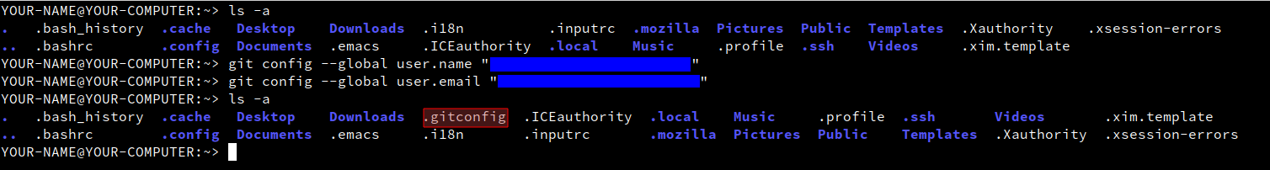
Type “ls -a” again, and there should now be a .gitconfig file.
Close your terminal to make sure it refreshes. We’re almost done!

Pulling, committing, Pushing
AKA the important bits!
Think for a second where you’d like to place your repos. I personally like having a folder named “GitHub” in my home directory.
I’ll create one with mkdir GitHub, and I’ll cd GitHub/ into it. This can be named anything, located anywhere. If you’d like an “invisible” folder, for example, you could name it .github. You could also create a folder called “Projects” inside the folder called “Documents”. You’d mkdir ~/Documents/Projects and cd Documents/Projects/ in that case.

Now, in your web browser, go to the repo you created. In my case, it’d be https://github.com/MY-NAME/GITHUB-TUTORIAL.
Then, in the upper right hand corner, you should see a green <> Code button. Click on the Code dropdown, select GitHub CLI (In my case, gh repo clone MY-NAME/GITHUB-TUTORIAL ) and copy the command.
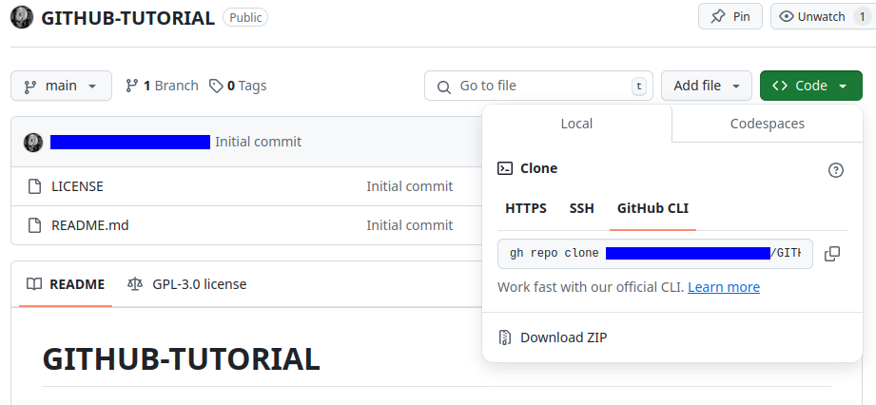

Go ahead and put this in the terminal. Make sure you’re in the right folder! “pwd” will print the working directory.
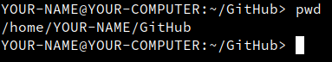

And then paste your command!
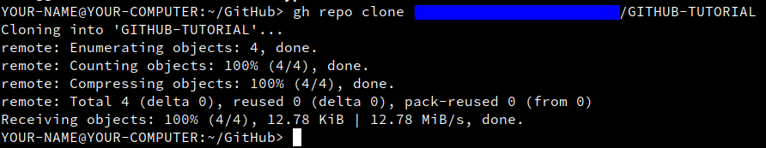

It’s a brand new repo with barely anything in it, so that only took a second. Make sure everything looks correct.

I now have a folder called GITHUB-TUTORIAL in my GitHub folder. Great! Organized just the way I like! :-)
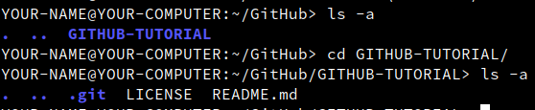
I took the liberty of cd’ing into this folder, and if you’re following along in the terminal, you should too. Nothing is stopping you from switching to GNOME’s Files, KDE’s Dolphin, or XFCE’s Thunar, if that’s more comfortable for you.

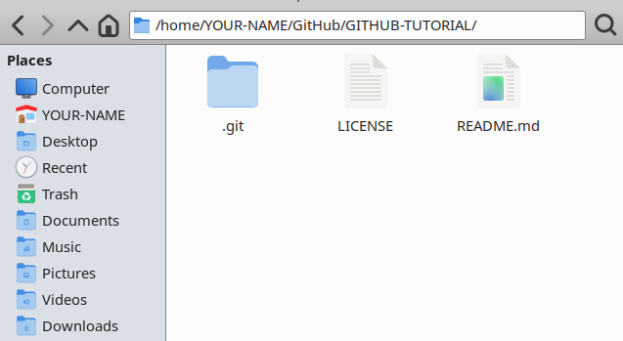

I did press CTRL+H to show hidden files/folders. You might not immediately see .git if you didn’t.

All right, now let’s make some changes!
I’ll go ahead and create a text file (Example.txt) in my favorite text editor, add an image (“Preview.png”), and create another folder called “Folder” that contains a little shell script (“Neat-o.sh”). Naturally, this will be completely different for you, based on what you’re working on. :-)

The tree command will show exactly what I’ve got in this folder. (I used pwd to clearly show what folder I’m in.)
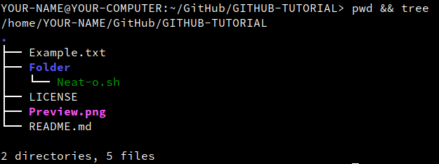

All right, this all looks good. Let’s get this uploaded to GitHub, shall we?
Make sure you’re in the correct folder. I just did, but it’s always good to confirm.
We’ll add everything in this folder, marking everything for upload. Type this: git add .
Note that there’s a period at the end, that’s very important!

Now we’ll commit the changes with a custom message: git commit -m "Yippee! My first commit! How exciting! :) "
Everything between the quotes will be added as a little message on GitHub. If you don’t want to add any note, remove the -m "Yippee! My first commit! How exciting! :) "

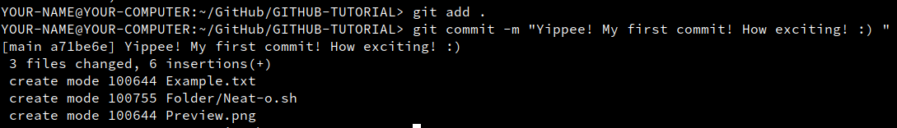
All right, this looks correct! Everything is ready for upload, so we’ll type: git push

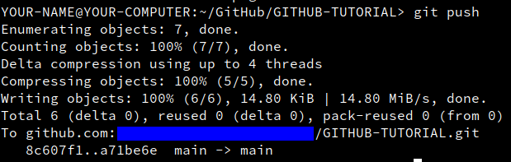
This looks good, so let’s look at the repo in our web browser.

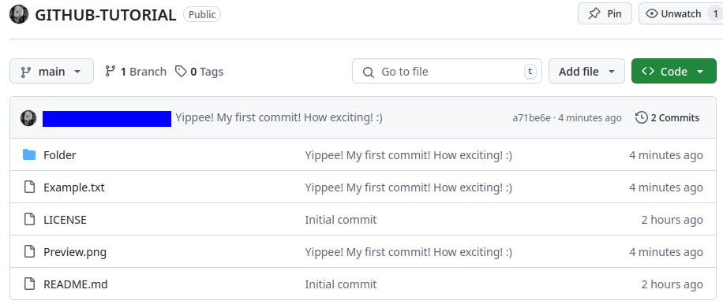

Those look like my files, all right! Now let’s make sure it added the shell script in the Folder.
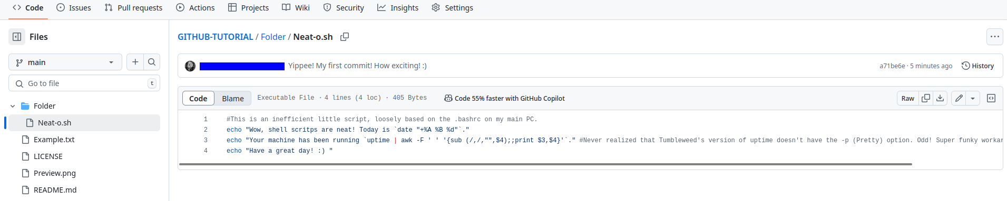
Perfect! Everything’s there.

Fin!
So, this was a very detailed, step-by-step guide on getting GitHub CLI set up. Moving forward, you can simply git add . , git commit, and git push all your changes from the terminal. Hopefully this will be helpful to other people. If not, I’m sure I’ll need to rely on this guide again soon enough! :-)

